Fraction Concepts

4.NF.A & 4.NF.B Conceptual Understanding Mini-Assessment by Student Achievement Partners

OVERVIEW
This mini-assessment is designed to illustrate some of the fraction concepts listed in clusters 4.NF.A and 4.NF.B, which set an expectation for students to deepen their understanding of fraction equivalence and ordering and develop their understanding of operations on fractions. This mini-assessment is designed for teachers to use either in the classroom, for self-learning, or in professional development settings to:
- Evaluate students’ understanding of aspects of 4.NF.A and 4.NF.B before or after teaching this material;
- Gain knowledge about assessing conceptual understanding of fraction equivalence, ordering, and operations;
- Illustrate CCR-aligned assessment problems;
- Illustrate best practices for writing tasks that allow access for all learners; and
- Support mathematical language acquisition by offering specific guidance.

MAKING THE SHIFTS
This mini-assessment attends to Focus as it addresses fraction equivalence and ordering, along with students’ developing understanding of operations on fractions, which are at the heart of the grade 4 standards and a key component of the Major Work of the Grade. It illustrates the Coherence of the CCSS across grades as the questions extend grade 3 understandings of fractions and operations on whole numbers. These clusters in 4.NF and this mini-assessment target conceptual understanding, one of the three elements of Rigor.

A CLOSER LOOK
4.NF.A. Extend understanding of fraction equivalence and ordering.
In grade 4, students expand on early understandings of fraction equivalence from grade 3 to arrive at a more general understanding that $\frac{n×A}{n×B}$ is equivalent to $\frac{A}{B}$. Working with this understanding, students now have the ability to compare any two fractions by either creating a common denominator, creating a common numerator, or comparing the fractions to a benchmark fraction. Denominators in grade 4 are limited to 2, 3, 4, 6, 8, 10, 12, and 100.
The questions on this mini-assessment address some, but not all, concepts in clusters 4.NF.A and 4.NF.B. Fraction equivalence (4.NF.A.1), fraction comparison (4.NF.A.2), and multiplication of a fraction by a whole number (4.NF.B.4) are assessed; addition and subtraction of fractions (4.NF.B.3) is not assessed. Conceptual understanding is largely assessed by short questions that are either free of context or have little context. The short contextual problems (for example, items 3 and 8) help students attach meaning to the operation of multiplication and make sense of multiplication problems. See the annotations in the answer key for discussion of how the questions assess conceptual understanding.
4.NF.B. Build fractions from unit fractions by applying and extending previous understandings of operations on whole numbers.

SUPPORT FOR ENGLISH LANGUAGE LEARNERS
This lesson was designed to include specific features that support access for all students and align to best practice for English Language Learner (ELL) instruction and assessment. Go here to learn more about the research behind these supports. Features that support access in this mini-assessment include:
- Tasks that allow for multi-modal representations, which can deepen understanding of the mathematics and make it easier for students, especially ELLs, to give mathematical explanations.
- Tasks that avoid unnecessarily complex language to allow students, especially ELLs, to access and demonstrate what they know about the mathematics of the assessment.
Prior to this mini-assessment, ensure students have had ample opportunities in instruction to read, write, speak, listen for, and understand the mathematical concepts that are represented by the following terms and concepts:
- whole number
- equivalent
- expression
- equation
- equal
- number line diagram
- fractions
- numerator
- denominator
Students should engage with these terms and concepts in the context of mathematical learning, not as a separate vocabulary study. Students should have access to multi-modal representations of these terms and concepts, including: pictures, diagrams, written explanations, gestures, and sharing of non-examples. These representations will encourage precise language, while prioritizing students’ articulation of concepts. These terms and concepts should be reinforced in teacher instruction, classroom discussion, and student work (for example, through engagement in mathematical routines).
ELLs may need support with the following Tier 2 words found in this mini-assessment:
- sketch
- show
- describe
- point
- space
- place
- check
In preparation for giving this mini-assessment, teachers should strive to use these words in context so they become familiar to students. It will be important to offer synonyms, rephrasing, visual cues, and modeling of what these words mean in the specific contexts represented in the items in this mini-assessment. Additionally, teachers may offer students the use of a student-friendly dictionary, or visual glossary to ensure they understand what is being asked of them in each item.
Sketch | 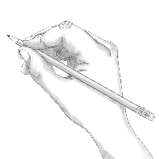
Point | •
Locate | •
An example of a visual glossary for student use.

Name: Date:

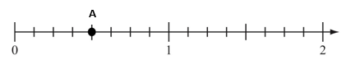
- Point A is shown on the number line diagram below.

Write three equivalent fractions for point A.

- . Write a number in every box to make true equations.

  - Place a point at $\frac{5}{4}$ on the number line diagram below

  - Write a fraction equivalent to$\frac{5}{4}$. Your fraction must have a denominator of 12. Use words or a diagram to show that your fraction is equivalent to$\frac{5}{4}$.

- Quan poured $\frac{2}{5}$ gallon of paint into an empty container. Marisa poured $\frac{3}{5}$ gallon of paint into the container. How much paint is in the container now? _____________ gallon(s).
- Nicole gives $\frac{6}{8}$ cup of food to each of her rabbits every day. She has 7 rabbits. How many cups of food will Nicole feed to the rabbits every day?
Select the true statement.
- Between 4 and 5 cups of food every day
- Between 5 and 6 cups of food every day
- Between 6 and 7 cups of food every day
- Between 7 and 8 cups of food every day

  - Write three fractions equivalent to$\frac{40}{10}$ . All three numerators must be less than 40.

  - Sketch a number line diagram and place all three fractions on it. Then, describe what you notice.

When placing all three fractions on the number line I notice that

_________________________________________________________.

- Decide whether each expression is equal to 5 × $\frac{2}{4}$ . Check the correct box for each row.

 | Equal to 5 × $\frac{2}{4}$ | Not Equal to 5 × $\frac{2}{4}$
2 × $\frac{1}{20}$
5 × $\frac{4}{8}$
10 × $\frac{1}{4}$

- Marcus buys 10 yogurt pouches. A full pouch contains $\frac{2}{3}$ cup of yogurt.
How many cups of yogurt, in total, are in all 10 pouches?
Name: Date:

- Point A is shown on the number line diagram below.

Write three equivalent fractions for point A.

Sample answers include: $\frac{4}{8}$, $\frac{2}{4}$, $\frac{1}{2}$
(Students should receive full credit
for any three fractions equivalent
to $\frac{4}{8}$.)
4.NF.A.1 requires students to recognize and generate equivalent fractions. This question scaffolds the understanding by offering a number line diagram for students to use as a tool
- Write a number in every box to make true equations.
  - $\frac{7}{5}=\frac{24×7}{24×5}$
  - $\frac{15}{10}=\frac{5×3}{5×2}$
Sample answer below
  - $\frac{67}{100}=\frac{10×67}{10×100}$
(Students should receive credit for any pair of numbers in part c that are equal to each other.)

  - Place a point at $\frac{5}{4}$ on the number line diagram below.
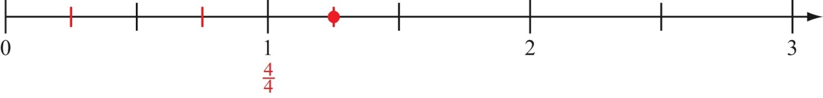
This task can help students realize that “fractions” can include values larger than 1.
Write a fraction equivalent to $\frac{5}{4}$. Your fraction must have a denominator of 12. Use words or a diagram to show that your fraction is equivalent to $\frac{5}{4}$.
Sample response using number line: I can divide each quarter into three smaller parts so there are 12 equal intervals between 0 and 1 (see below).
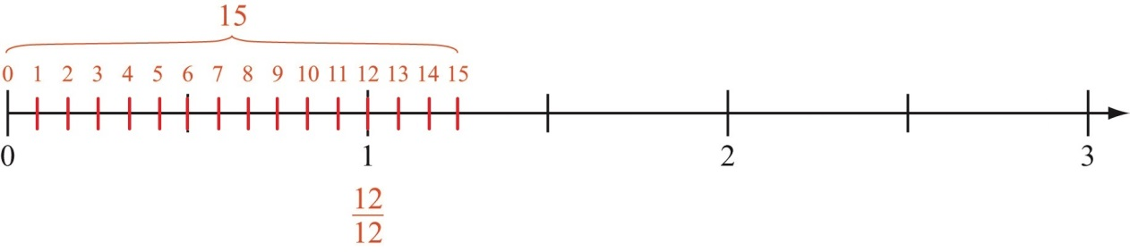
Sample response using fraction model: I can show 5/4 as a model and then split each piece up into three equal pieces to make 12ths (see below).
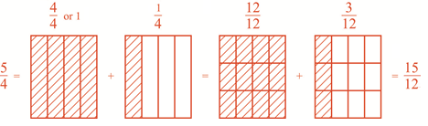

- Quan poured $\frac{2}{5}$ gallon of paint into an empty container. Marisa poured $\frac{3}{5}$ gallon of paint into the container. How much paint is in the container now? _____________ gallon(s).
4.NF.B.3.d: Solve word problems involving addition and subtraction of fractions, referring to the same whole and having like denominators, e.g., by using visual fraction models and equations to represent the problem.
$\frac{5}{5}$ gallon or 1 gallon

- Nicole gives $\frac{6}{8}$ cup of food to each of her rabbits every day. She has 7 rabbits. How many cups of food will Nicole to feed the rabbits every day?
Select the true statement.
- Between 4 and 5 cups of food every day
- Between 5 and 6 cups of food every day
- Between 6 and 7 cups of food every day
- Between 7 and 8 cups of food every day
b. Between 5 and 6 cups of food every day

  - Write three fractions equivalent to $\frac{40}{10}$ . All three numerators must be less than 40.
$\frac{20}{5}$, $\frac{4}{1}$ ,$\frac{8}{2}$
This question is similar to #1 in that students must generate equivalent fractions, but without the given tool of a number line diagram. This question assesses deeper conceptual understanding as students must generate equivalent fractions with smaller numerators, rather than larger ones (e.g., 80/20). Students may notice that, because 40 and 10 share the factor 2, they can write 40 = 2*20 and 10 = 2*5, so that 40/10 = 2*20/2*5. The principle of equivalent fractions then implies 40/10 = 20/5. (As this example illustrates, the common technique of “cancelling a common factor” is just another way to generate an equivalent fraction based on the principle a/b = na/nb.)

  - Sketch a number line diagram and show all three fractions on it. Then, describe what you see.

When placing all three fractions on the number line I notice that

_________________________________________________________.
Student sketch should show his or her fractions.
- Decide whether each expression is equal to 5 × $\frac{2}{4}$ . Check the correct box for each row.
This question assesses student understanding of multiplication and connects prior knowledge of equivalent fractions.
 | Equal to 5 × $\frac{2}{4}$ | Not Equal to 5 × $\frac{2}{4}$
2 × $\frac{1}{20}$ |  | X
5 × $\frac{4}{8}$ | X
10 × $\frac{1}{4}$ | X

- Marcus buys 10 yogurt pouches. A full pouch contains $\frac{2}{3}$ cup of yogurt.
How many cups of yogurt, in total, are in all 10 pouches?

$\frac{20}{3}$ OR equivalent

For more on the Major Work of the Grade, see achievethecore.org/focus.

